[ADD LOGO HERE]
Farm Biodiversity Plan

This plan outlines the biodiversity assets on [INSERT FARM NAME] and outlines actions to be taken to protect and preserve natural capital on the farm.

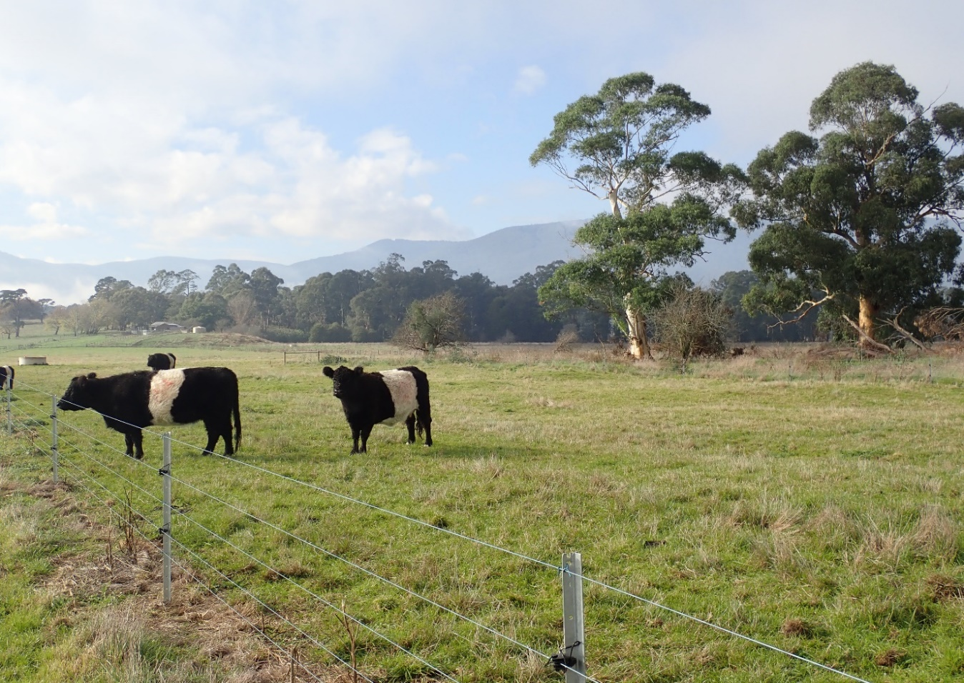

[ADD CONTACT DETAILS HERE]

Farm Biodiversity Plan

Date created | Click or tap here to enter text.
Farm name | Click or tap here to enter text.
Address | Click or tap here to enter text.
Bioregion | Click or tap here to enter text.
Local government area | Click or tap here to enter text.
Ecological Vegetation Class/es on farm (or nearby) | Click or tap here to enter text.

Native vegetation
Native vegetation on/bordering the property | Click or tap here to enter text.
Native vegetation on property that forms part of a vegetation corridor | Click or tap here to enter text.
Threatened flora (plants) in local government area | Click or tap here to enter text.

Native animals
Threatened fauna (animals) in farm's local government area | Click or tap here to enter text.
Threatened plant and animal species known to exist on the farm | Click or tap here to enter text.

Action plan
Management of environmental and pasture weed species | Click or tap here to enter text.
Management of pest animals | Click or tap here to enter text.
Actions to improve vegetation and habitat and support native plants and animals:
In crop/pasture | Click or tap here to enter text.
Re-vegetation | Click or tap here to enter text.
Wetlands, waterways and water storage areas | Click or tap here to enter text.
Riparian areas | Click or tap here to enter text.
Other actions | Click or tap here to enter text.

Other notes
Click or tap here to enter text.

